KEY STAGE 1 EASTER COLOURING RAFFLE

Please affix £1
CHILD’S NAME: …………………………………….

CLASS: ………………………………………………….
Please return to school by 25TH March

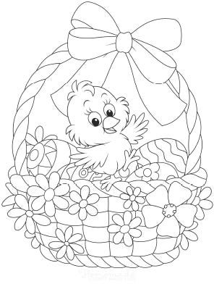

KEY STAGE 2 EASTER DRAWING RAFFLE

CHILD’S NAME: …………………………………….

CLASS: ………………………………………………….
Please return to school by 25th March

Please affix £1


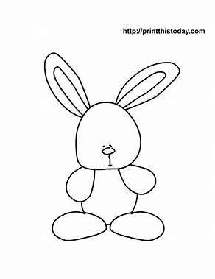
Instructions:
Please draw an Easter themed picture in the box above.
Be as creative as you can!
If you need some inspiration you can use one of these Easter bunnies in your scene - just cut out and glue into your picture.
Good Luck!!

